R. Reports Menu: M. Mismatched Parcel Report

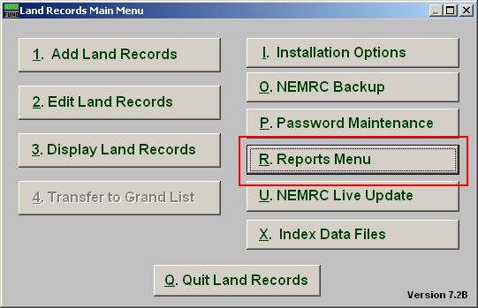
Click on “R. Reports Menu” from the Main Menu and the following window will appear:

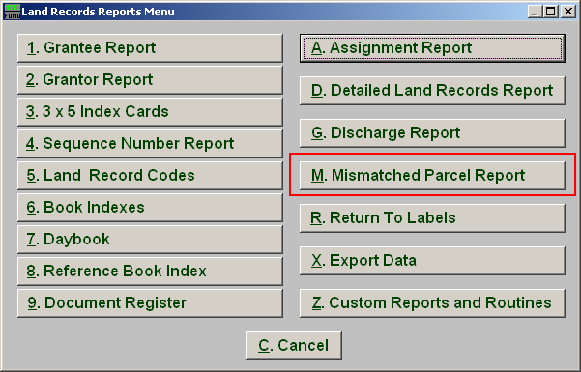
Click on “M. Mismatched Parcel Report” from the Reports Menu and the following window will appear:
Mismatched Parcel Report

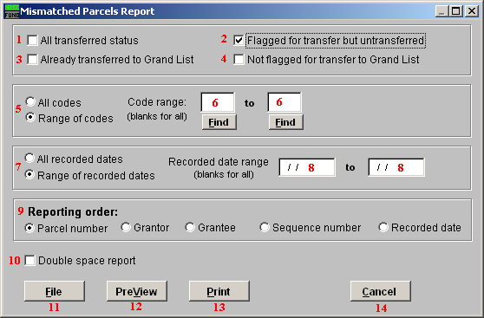
- All transferred status: Select this option for records that are ready to be and have already been transferred to the Grand List. (Items 2 & 3).

- Flagged for transfer but untransferred: Select this box for records that are ready to be transferred but have not been. This allows testing for proper parcel number in the Grand List file before the transfer is performed.

- Already transferred to Grand List: Select this box for records that have already been transferred to the Grand List. This will report parcel numbers that have been transferred but had no match in the Grand List when sent.

- Not flagged for transfer to Grand List: Select this box for records that are not marked to be transferred and have never been transferred to the Grand List.

- All codes OR Range of codes: Choose whether this report is for All codes or a Range of codes.

- Code range: If you chose Range of codes, these fields become available. Enter the starting and ending code you wish to include in this report, or click “Find” and select from there. Leave blank for all.

- All recorded dates OR Range of recorded dates: Choose whether this report is for All recorded dates or a Range of recorded dates.

- Recorded date range: If you chose Range of recorded dates, these fields become available. Enter the starting and ending dates you wish to include in this report. Leave blank for all.

- Reporting order: Select what order you want this report to print in.

- Double space report: Click this box to have this report be double-spaced instead of single-spaced. This is for marking up or visual appearance.

- File: Click this button to save on this computer. Refer to GENERAL FILE for more information.

- PreView: Click this button to preview. Refer to GENERAL PREVIEW for more information.

- Print: Click this button to print. Refer to GENERAL PRINTING for more information.

- Cancel: Click “Cancel” to cancel and return to the previous screen.

